LPC based Voice Morphing
Peramanallur Ranganathan Gurumoorthy
University of Florida

Abstract

This Project describes a technique to morph speech signals between source and target speaker. We may assume the source speaker to be a Man and the target speaker to be a Woman or a more interesting idea would be that the source speaker could be a musical note and the target speaker the next immediate musical note. When we morph between the source speaker (one musical note) and the target speaker (the next musical note) we can observe if we can find some interesting note in between. To make it simplified we will consider morphing only at the phoneme level. There are three important parts associated with speech morphing: LPC (or other methods) based source-filter decomposition, Interpolation of signals between the Source and Target signal, combining everything together. The first Part of the Project would be to implement Voice Morphing using the LPC coefficients. The other part of the project would involve better interpolation techniques so that effective morphing occurs. There are various techniques to interpolate between two speech signals but we will try to focus on the Line Spectrum Pair Method. We make sure that each instant of the phoneme of the first speaker is matched with that of the second speaker. Now that we know the LPC or LSF coefficients of the Source and Target we can interpolate between them. We should also vary the Pitch so that we are able to traverse different pitch frequencies. Now when we play all the signals together we must observe a smooth transition from the source speech signal to the target speech signal. Especially when we make a transition from one musical note to another we must find the morphing pleasant. We will try to come up with ideas to solve this problem. This is the core idea of the Project.

- Introduction

Voice Morphing is a technique for modifying a (source) speaker's speech to sound as if it were spoken by a different (target) speaker. We need to change the Pitch form the Source Speaker to that of the Target Speaker in gradual steps. We have implemented the LPC based Voice Morphing and Have tried other methods like LSF based Voice Morphing. In this project we are morphing from a Male Speaker to the Female Speaker. We consider morphing at the phoneme level as the process is complicated and requires time. The English Phoneme ‘eh’ has been considered. We have also tried to implement morphing between two Guitar Sounds.

- The Process

We record the Speech signal from both the Source and Target Speaker. We know that the Excitation Signal gives us information about who the speaker is and the filter coefficients give us information about what is being said. We plot the Time Domain response of both the Speakers. We can clearly see that even though both the Speakers utter the same phoneme there are lot of variations in the time domain response other than the pitch. This is one of the reasons why we are worried about what is being said.

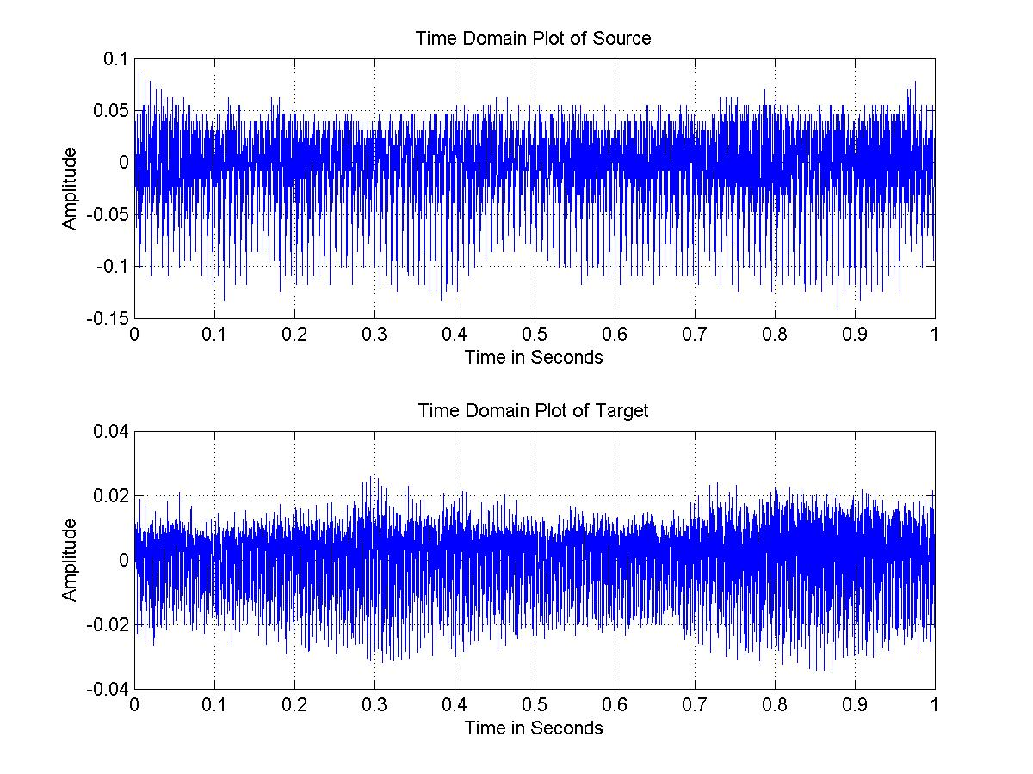
Figure1.

We pass the speech signal through an inverse filter to obtain the excitation signal. Voice morphing is achieved by changing the pitch of the source speaker to that of target speaker. To change the pitch we pitch shift the excitation signal of the source so long that we final obtain the pitch of the target. As we stated earlier we need to consider the filter coefficients too. This can be evident from this figure. There is a slight variation in what is being said. This arises from the fact that there can be differences in the way people speak their accent etc. This becomes very important when we try to morph real speech.

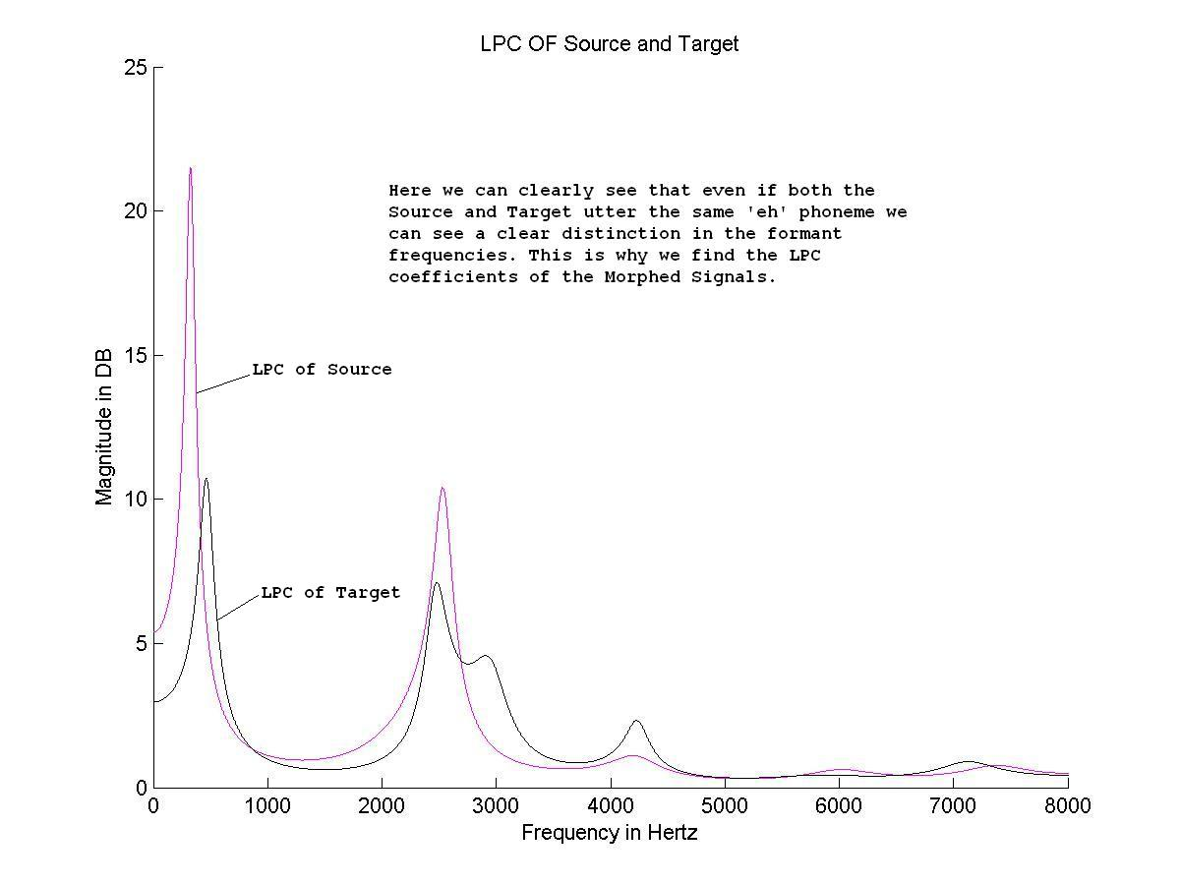
Figure 2.

The LPC coefficients are calculated for both the Source and the Target. A crude method of interpolating between the source and target speaker would be to obtain the weighted mean of the coefficients between the source and the target speech signals, but we cannot know for sure that these coefficients are stable. When we are looking at the phoneme level the probability of getting an unstable pole would be very small but when we try to implement this system at a higher level we are sure to have problems. The new LPC coefficients can be calculated from this simple formula.

Morphed LPC = [{Constant * (LPC Source)} + {(1 – Constant) * (LPC Target)}]

The constant determines how the new morphed signal will sound. For example a value of 0.5 for the constant indicates that the Morphed signal is midway between the Source and Target speech. That is its pitch will be midway between the Source and the Target. This can be shown from this figure. It is clear from the figure that the morphed signal is traversing from the source to the target.
However as stated earlier we cannot be sure that the poles obtained from the above formula can be stable. This will lead to ringing effect in the Morphed Signals. This is the Reason for using the LSF Coefficients. LSF’s are calculated from the LP poles in a technique that yields two sets of interleaved zeros on the unit circle. Representing the LPC filter in the LSF domain ensures its stability and is thus appropriate for coding and interpolation. We used the Matlab command poly2lsf which converts the prediction filter coefficients to line spectral frequencies. We convert back to filter coefficients using the lsf2poly command.

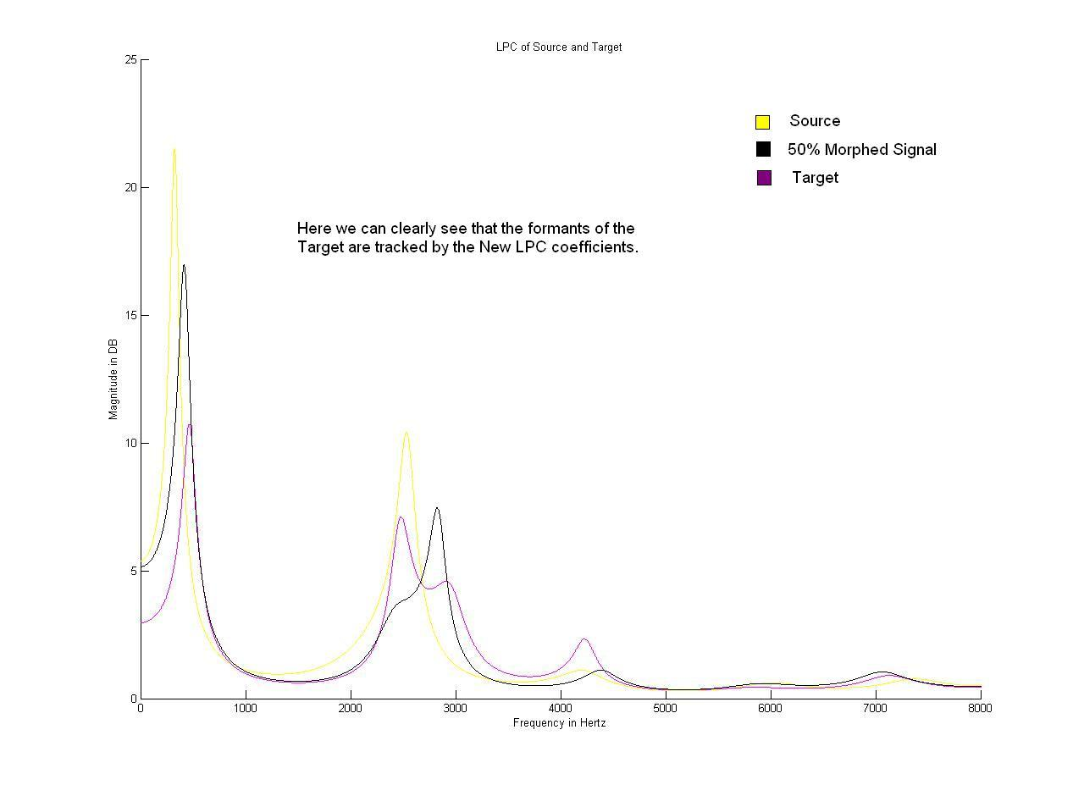

Figure 3.

If we have a look at the Pole Zero plot of the Morphed Signals we can understand that the ’what is being said’ information is slowly moving from that of the source speaker to that of the target speaker. By Using the LSF coefficients the ringing effect is supposed to be subdued however using LPC or LSF coefficients did not show great difference in the results as we are considering only morphing at the phoneme level.

An interesting observation looking at the Pole Zero plot is that even though we use a linear equation to find the new poles we seem to see that the morphed pole zero pattern is not linear in nature.

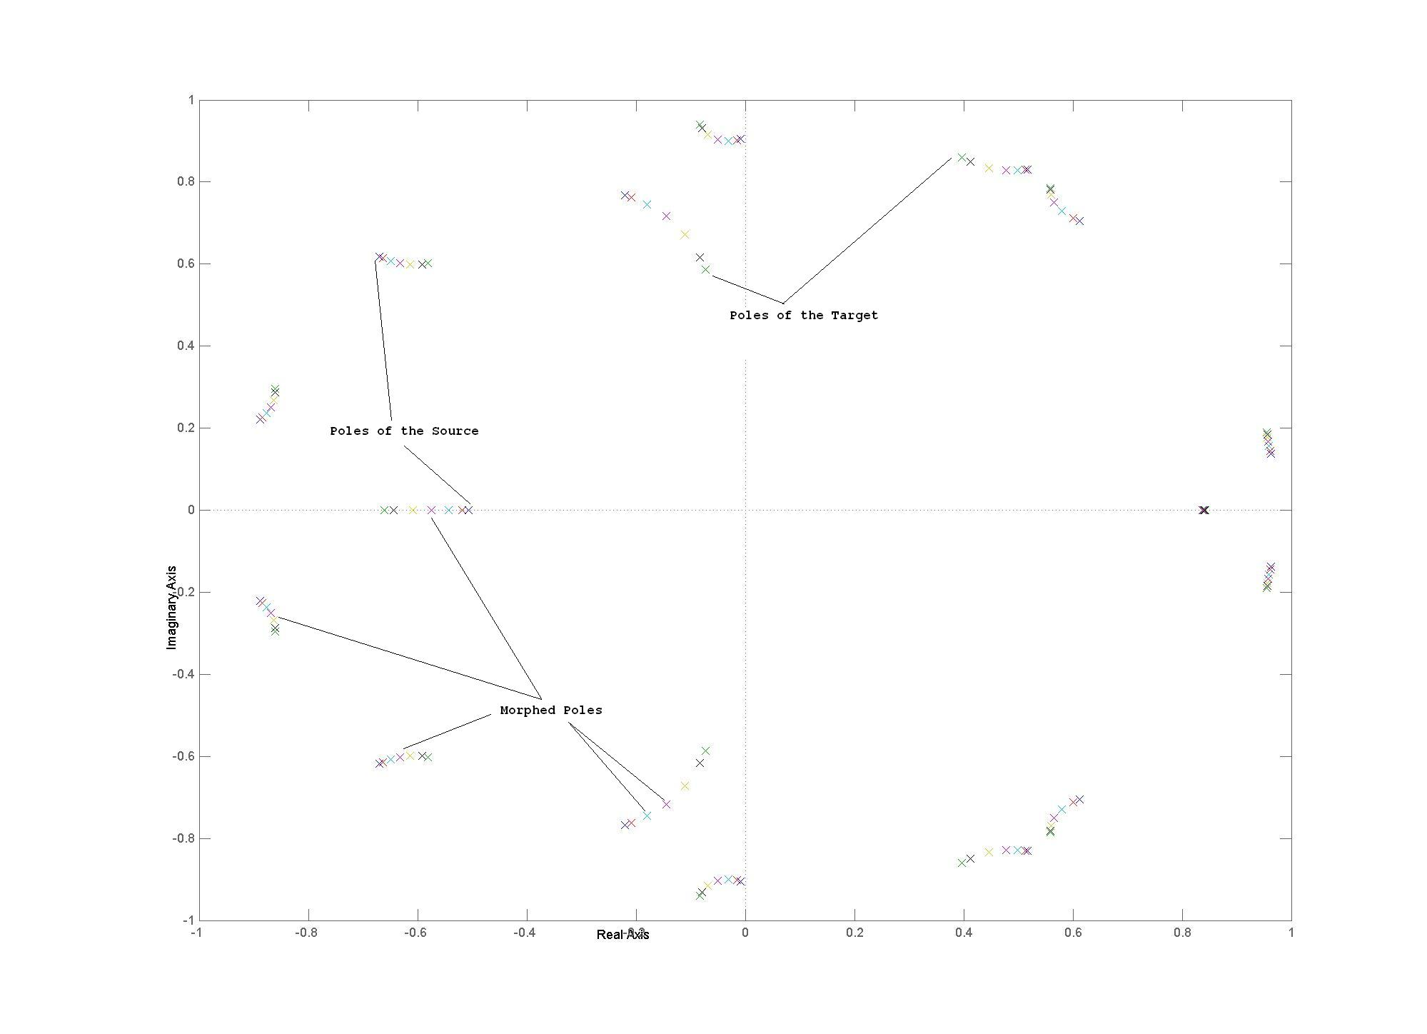Figure 4.

Now that we have morphed the ‘what is being said information’ we need to look into the ‘who is the speaker’ information. The case of concern for us is that the Source speaker is a Man and Target Speaker is a Woman. The male pitch will be anywhere from 100Hz to 140Hz and the female pitch will be close to 220Hz. The conditions are similar here. So we need to mole from 100Hz to 200Hz in small steps so that effective morphing can be noticed. We pitch shift the excitation signal of the Source and the shifting constant ‘alpha’ indicates the ratio of the pitch shift to the original pitch.
The Figure shows a zoomed in time domain plot.

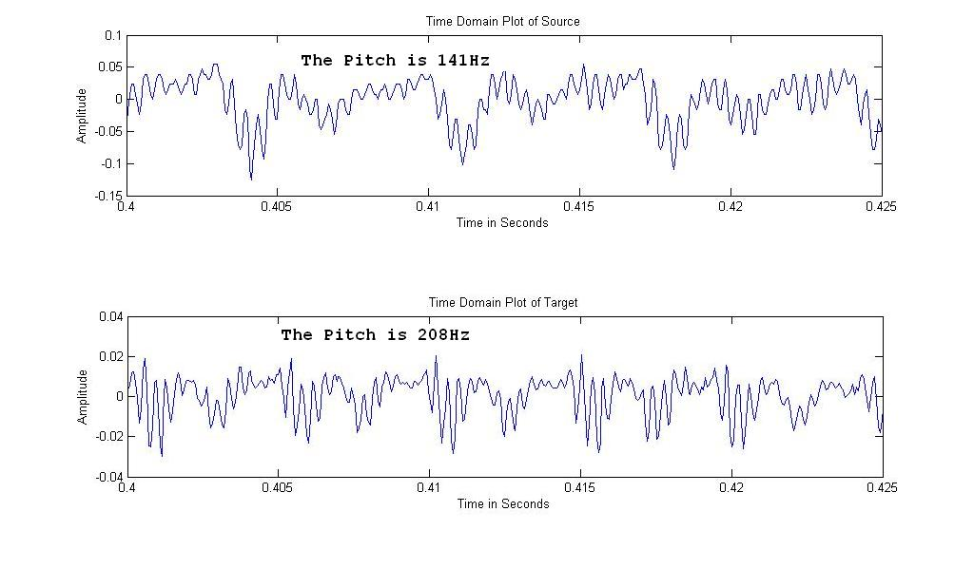

Figure 5.

The Pitch Shifting algorithm breaks the excitation signal into various blocks and introduces effects in the signal so that pitch shifting occurs. A common method used is to use fade in and fade out effects in each window which will time stretch the excitation signal. An important point to note is that now when the signal is time stretched it will last longer in time that the original signal. This is not the desired result so we have to resample the time stretched signal so that it is played at a faster rate so that pitch shifting can be affected. We repeat this procedure by changing the values of the Constant and Alpha to affect voice morphing. Now when we play the signals we can clearly see that we are able to slowly move from the source to the target and effective morphing occurs. The method for music morphing is similar to that of voice morphing. We have used to same algorithm to do music morphing. The Pitch of the Source guitar sound is 111Hz and that of the Target is 185Hz. In case of music morphing the ‘what is being said’ information are entirely different but the morphed LPC coefficients will take care of that problem.

The Figure shows that the pitch slowly increases from the source to the target.
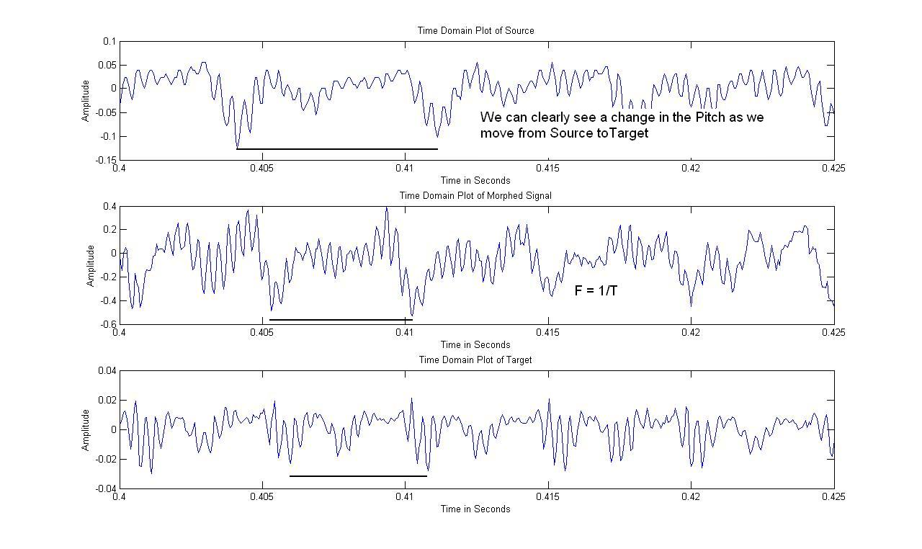
Figure 6.

- Results

We have achieved morphing between the Source and the Target. Be it Voice morphing or Music morphing the results are promising. We would like to further work on this and try to implement a Voice morphing system rather than a Phoneme Morphing System. Also we would like to use different methods to make the morphed signal sound more realistic. Lots of Voice Morphing techniques have come up in the recent years and this is only an attempt to give an insight into what Voice Morphing is and its applications.

- References

- DFW-based Spectral Smoothing for Concatenative Speech Synthesis -- Hartmut R. Pfitzinger
- Unsupervised Speech Morphing between Utterances of any Speakers -- Hartmut R. Pfitzinger
- Automatic Audio Morphing -- Malcolm Slaney, Michele Covell and Bud Lassiter
- Spectral Smoothing for Speech Segment Concatenation -- D.T. Chappell, J.H.L. Hansen

- Appendix

Matlab Codes

% Note
% This Program cannot be directly run for the Outputs.
% A Procedure has to be followed which is as stated below.
% Run Part One of the Program
% Continue Running Part Two
% Part Three is required if we wish to to Proceed using the LPC
% Coefficients
% If we wish to go by the LSF method Skip Part Three and directly go to
% Part Four
% Then Run the Time Stretch Algorithm
% Come back and Run Part Six for Each value of Stretch
% Remember to resample accordingly.

%%%%%%%%%%%%%%%%%%%%%%%%%%%%%%%%%%%%%%%%

% Part One

%%%%%%%%%%%%%%%%%%%%%%%%%%%%%%%%%%%%%%%%

% Calculating the LPC Coefficients and obtaining the Residue
% My Speech Signal
[Source,Fs,bits] = wavread('eh4.wav');
wavplay(Source,16000);
t = 0:1/16000:1;
figure(1);
subplot(2,1,1);
plot(t,Source);
xlabel('Time in Seconds');
ylabel('Amplitude');
title('Time Domain Plot of Source');
SOURCE = fft(Source);
f = 0:1:16053;
figure(2);
plot(f,abs(SOURCE));
xlabel('Frequency in Hertz');
ylabel('Magnitude');
title('Magnitude Spectrum of Source');
grid on;
% Magnitude in DB
figure(3);
semilogy((abs(fft(Source,Fs))),'m');
xlabel('Frequency in Hertz');
ylabel('Magnitude in DB');
title('Log Magnitude Spectrum of Source');
% Find lpc coefs
[a,g]=lpc(Source,14);
[h,w]=freqz(1,a,Fs/2);
L = poly2lsf(a);
% Plot the magnitude of freq resp
figure(3)
hold on
semilogy(abs(h), 'k')
r=roots(a);
r=r(imag(r)>0.01);
freq=sort(atan2(imag(r),real(r))*Fs/(2*pi));
for j=1:length(freq)
fprintf('Formant %d Frequency %.1f\n',j,freq(j));
end
figure(4);
H = tf([1],[a]);
pzmap(H)
[res,p,k] = residue(1,a);
R = tf([a],[1]);
hold on
[Poles,XI] = sort(real(p));
Ascend_poles = p(XI);

% Compute the residue, also called this e(n)
resi=filter(real(a),g,Source);
% Plot residue vs. the original speech signal
figure(5)
plot(Source,'k')
hold on
plot(t,resi/max(resi), 'y')
soundsc(resi);
wavwrite(resi, 16000, 16,'Residue');

%%%%%%%%%%%%%%%%%%%%%%%%%%%%%%%%%%%%%%%%

% Part Two

%%%%%%%%%%%%%%%%%%%%%%%%%%%%%%%%%%%%%%%%

% Target Speech Signal
% Calculating the LPC Coefficients and obtaining the Residue
[Target,Fs_target,bits_target] = wavread('Target.wav');
wavplay(Target,16000);
t_target = 0:1/16052:1;
figure(1);
subplot(2,1,2);
plot(t_target,Target);
xlabel('Time in Seconds');
ylabel('Amplitude');
title('Time Domain Plot of Target');
TARGET = fft(Target);
f_target = 0:1:16052;
figure(7);
plot(f_target,abs(TARGET));
xlabel('Frequency in Hertz');
ylabel('Magnitude');
title('Magnitude Spectrum of Target');
grid on;
% Magnitude in DB
figure(8);
semilogy((abs(fft(Target,Fs_target))),'m');
xlabel('Frequency in Hertz');
ylabel('Magnitude in DB');
title('Log Magnitude Spectrum of Target');
% Find lpc coefs
[a_target,g_target]=lpc(Target,14);
[h_target,w_target]=freqz(1,a_target,Fs_target/2);
L_Target = poly2lsf(a_target);
% Plot the magnitude of freq resp
figure(8)
hold on
semilogy(abs(h_target), 'k')
r_target=roots(a_target);
r_target=r_target(imag(r_target)>0.01);
freq_target=sort(atan2(imag(r_target),real(r_target))*Fs_target/(2*pi));
for j_target=1:length(freq_target)
fprintf('Formant %d Frequency %.1f\n',j_target,freq_target(j_target));
end
figure(4);
H_target = tf([1],[a_target]);
pzmap(H_target)
[res_target,p_target,k_target] = residue(1,a_target);
R_target = tf([a_target],[1]);
[Poles_target,XI_target] = sort(real(p_target));
Ascend_poles_target = p_target(XI_target);
hold on

% Compute the residue, also called this e(n)
resi_target=filter(real(a_target),g_target,Target);
% Plot residue vs. the original speech signal
figure(10)
plot(Target,'k')
hold on
plot(resi_target/max(resi_target), 'y')
soundsc(resi_target);
wavwrite(resi_target, 16000, 16,'Residue_Target');

%%%%%%%%%%%%%%%%%%%%%%%%%%%%%%%%%%%%%%%%

% Part Three

%%%%%%%%%%%%%%%%%%%%%%%%%%%%%%%%%%%%%%%%

% Morphing the New Sounds

new_lpc_a1 = 0.9*a + 0.1*a_target;
[res_1 , p_1 , k_1] = residue(1,new_lpc_a1);
R_1 = tf([new_lpc_a1],[1]);
figure(4);
H_1 = tf([1],[new_lpc_a1]);
pzmap(H_1)

new_lpc_a2 = 0.7*a + 0.3*a_target;
[res_2 , p_2 , k_2] = residue(1,new_lpc_a2);
R_2 = tf([new_lpc_a2],[1]);
figure(4);
H_2 = tf([1],[new_lpc_a2]);
pzmap(H_2)

new_lpc_a3 = 0.5*a + 0.5*a_target;
[res_3 , p_3 , k_3] = residue(1,new_lpc_a3);
R_3 = tf([new_lpc_a3],[1]);
figure(4);
H_3 = tf([1],[new_lpc_a3]);
pzmap(H_3)

new_lpc_a4 = 0.3*a + 0.7*a_target;
[res_4 , p_4 , k_4] = residue(1,new_lpc_a4);
R_4 = tf([new_lpc_a4],[1]);
figure(4);
H_4 = tf([1],[new_lpc_a4]);
pzmap(H_4)

new_lpc_a5 = 0.1*a + 0.9*a_target;
[res_5 , p_5 , k_5] = residue(1,new_lpc_a5);
R_5 = tf([new_lpc_a5],[1]);
figure(4);
H_5 = tf([1],[new_lpc_a5]);
pzmap(H_5)

%%%%%%%%%%%%%%%%%%%%%%%%%%%%%%%%%%%%%%%%

% Part Four

%%%%%%%%%%%%%%%%%%%%%%%%%%%%%%%%%%%%%%%%

% We are Converting the LPC coefficients to LSF Coefficients for more
% Stability

% Morphed LSF coefficients

lsf_l1 = 0.9*L + 0.1*L_Target;
lsf_l2 = 0.7*L + 0.3*L_Target;
lsf_l3 = 0.5*L + 0.5*L_Target;
lsf_l4 = 0.3*L + 0.7*L_Target;
lsf_l5 = 0.1*L + 0.9*L_Target;

% LSF back to LPC
new_lpc_a1 = lsf2poly(lsf_l1);
new_lpc_a2 = lsf2poly(lsf_l2);
new_lpc_a3 = lsf2poly(lsf_l3);
new_lpc_a4 = lsf2poly(lsf_l4);
new_lpc_a5 = lsf2poly(lsf_l5);

%%%%%%%%%%%%%%%%%%%%%%%%%%%%%%%%%%%%%%%%

% Part Six

%%%%%%%%%%%%%%%%%%%%%%%%%%%%%%%%%%%%%%%%

% Different Sounds using LPC coefficients

% Getting the New Signal

% My Signal
Signal = filter(1,a,resi);
soundsc(Signal,16000);
Signal = Signal/max(Signal);
wavwrite(Signal, 16000, 16,'Signal_Source_1');
pause

% Morphed Signal 1
[Signal,Fs] = wavread('Modified_Residue');
Final_Output = resample(Signal,25,26);
Signal_Morphed_1 = filter(1,new_lpc_a1,Final_Output);
soundsc(Signal_Morphed_1,16000);
Signal_Morphed_1 = Signal_Morphed_1/max(Signal_Morphed_1);
wavwrite(Signal_Morphed_1, 16000, 16,'Signal_Morphed 1_1');
pause

% Morphed Signal 2
[Signal,Fs] = wavread('Modified_Residue');
Final_Output = resample(Signal,50,57);
Signal_Morphed_2 = filter(1,new_lpc_a2,Final_Output);
soundsc(Signal_Morphed_2,16000);
Signal_Morphed_2 = Signal_Morphed_2/max(Signal_Morphed_2);
wavwrite(Signal_Morphed_2, 16000, 16,'Signal_Morphed 2_1');
pause

%Morphed Signal 3
[Signal,Fs] = wavread('Modified_Residue');
Final_Output = resample(Signal,4,5);
Signal_Morphed_3 = filter(1,new_lpc_a3,Final_Output);
soundsc(Signal_Morphed_3,16000);
Signal_Morphed_3 = Signal_Morphed_3/max(Signal_Morphed_3);
wavwrite(Signal_Morphed_3, 16000, 16,'Signal_Morphed 3_1');
pause

%Morphed Signal 4
[Signal,Fs] = wavread('Modified_Residue');
Final_Output = resample(Signal,25,33);
Signal_Morphed_4 = filter(1,new_lpc_a4,Final_Output);
soundsc(Signal_Morphed_4,16000);
Signal_Morphed_4 = Signal_Morphed_4/max(Signal_Morphed_4);
wavwrite(Signal_Morphed_4, 16000, 16,'Signal_Morphed 4_1');
pause

%Morphed Signal 5
[Signal,Fs] = wavread('Modified_Residue');
Final_Output = resample(Signal,5,7);
Signal_Morphed_5 = filter(1,new_lpc_a5,Final_Output);
soundsc(Signal_Morphed_5,16000);
Signal_Morphed_5 = Signal_Morphed_5/max(Signal_Morphed_5);
wavwrite(Signal_Morphed_5, 16000, 16,'Signal_Morphed 5_1');
pause

% Target Signal
Signal_Target = filter(1,a_target,resi_target);
soundsc(Signal_Target,16000);
Signal_Target = Signal_Target/max(Signal_Target);
wavwrite(Signal_Target, 16000, 16,'Signal_Target_1');

%%%%%%%%%%%%%%%%%%%%%%%%%%%%%%%%%%%%%%%%

%%%%%%%%%%%%%%%%%%%%%%%%%%%%%%%%%%%%%%%%

